Organized Cupcake Shifts

The Cupcake Company is a local shop in Amarillo and Canyon Texas specializing in baked goods. The business is expanding to Dallas and larger areas making it crucial for it to get all affairs in order to manage efficiently from afar.

Problem:

The company is experiencing difficulties in scheduling its employees effectively. As of now, the scheduling method is manual, disorganized, and lacks coordination between departments, resulting in mistakes, inadequate use of assets, and poor work efficiency. This can and will lead to higher payroll costs and employee dissatisfaction.

Pains of problems:

* Loss of Time: Manual scheduling procedures cause delays in work assignments and shift levels of coordination, this can waste minutes to hours depending on how large the company is and causes deadlines to be delayed.
* Loss of Money: Poor scheduling results in overstaffing or understaffing, which unpredictably influences labor costs and hinders opportunities for cost savings. At my job, being overstaffed for the day with a few too many employees can result in hundreds of dollars lost in turnover. It is important to utilize employees wisely to maintain a positive ratio in business funds.
* Loss of Opportunity: Poor scheduling minimizes productivity and may cause the company to pass up chances to satisfy client requests.
* Increased Risk: Lack of thorough staffing and shift fluctuations pose a risk of errors, accidents, and compliance issues leading to potential liabilities and damage to reputation.

Software Solution:

Scheduling software is one solution the organization can use to address the dilemma. The goal of this software is to increase efficiency among employees, improve and automate the scheduling process, and better distribute resources. An orderly system can help avoid mistakes. See Figure 1 below for example.

Figure 1: Automatic scheduling systems

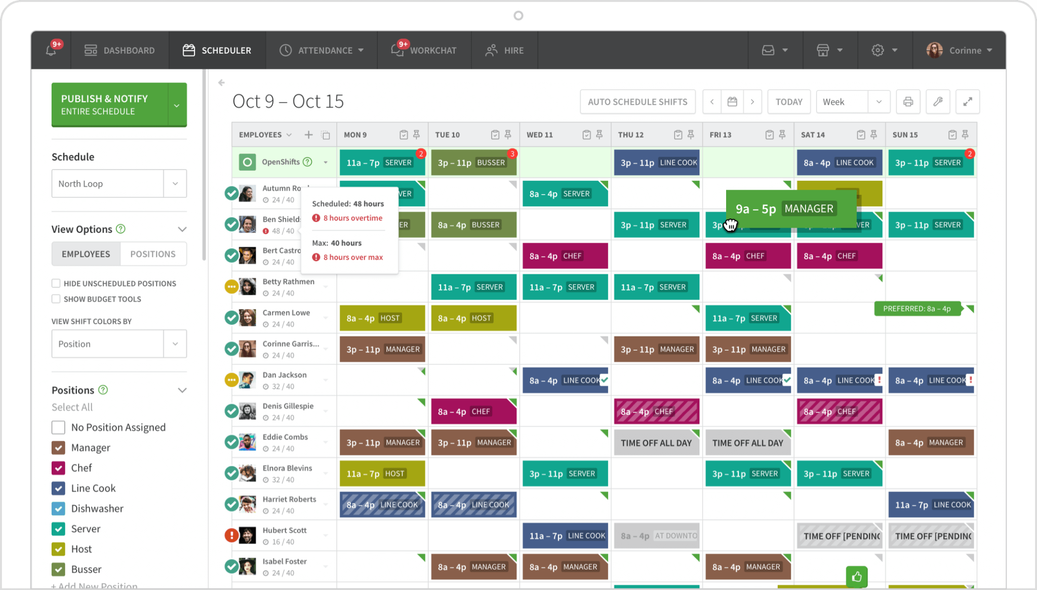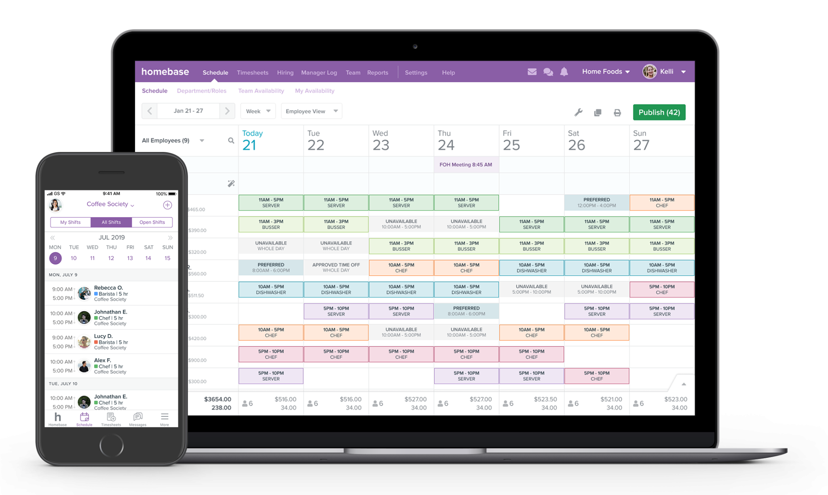

Problem solving:

This software addresses the scheduling problem by automating the scheduling process. Automated scheduling ensures and minimizes chances of overstaffing or understaffing. Analytics enable managers to monitor scheduling performance, find inefficiencies, and make data-driven decisions to improve workforce productivity. After researching the monthly costs of this implementation, I have found that it varies but ranges anywhere from 10-60 dollars a month. The Cupcake Company will need to assess these software companies to better understand which will work best for them personally. Setting up a new scheduling system can take anywhere from a day or a few to get everything filled out, including employees information for total access.

Improvement:

With software implemented, the scheduling process will be automated and optimized, improving efficiency, accuracy, and employee satisfaction. Managers will use the software to create and manage shift schedules, assign tasks to employees, and monitor workforce performance.

Conclusion:

In conclusion, the company is facing challenges in efficiently managing employee schedules. Currently, the scheduling process is manual, lacks organization, and suffers from poor coordination between departments. This has led to errors, underutilization of resources, and decreased work efficiency. These issues can result in increased payroll expenses and decreased employee satisfaction. Addressing the scheduling challenge with a management software system offers significant benefits for the company including improved efficiency, cost savings, and less mistakes. By automating the scheduling process, the company can improve productivity, meet customer and employee demands, and drive business success.